- Overview
- This document defines the required adaptations for the Triplex load cells calibration wizard.
In Triplex there are 8 cartridges comparing to 4 cartridges in most Eden’s and Connex’s, and since it is confusing to detect the cartridges only by the naming convention, we will visually guide the user for the correct cartridge location. As well, all the calibrations will appear in only one comined wizard screen in order to avoid monotone work load during the process.
- Objectives
  - Make the load cell calibration wizard (Customer) and the load cell calibration area in the service area “Idiot proof” and prevent human mistakes which are sourced by the unclear GUI.

- Current implementation problem
  - User needs to detect the cartridge he needs to calibrate by it name only which is not intuitive.
  - The current process is sequential and performing 8 sequential operations might be too much and annoying.
  - Current wizard screen in Connex version 57.1:
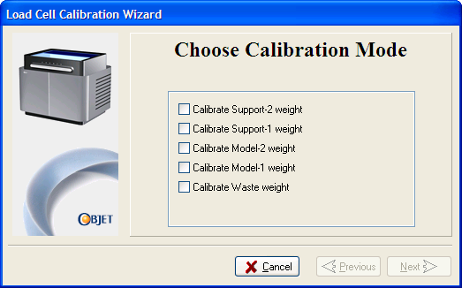
Current in Connex 57.1 (Ref)

- Detailed solution description
  - This wizard is available via the options menu:
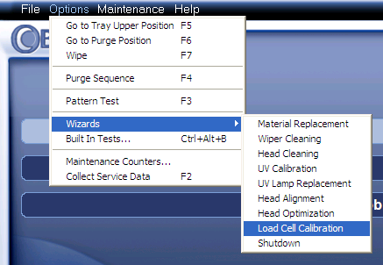
  - screen 1: welcome screen (T.W).
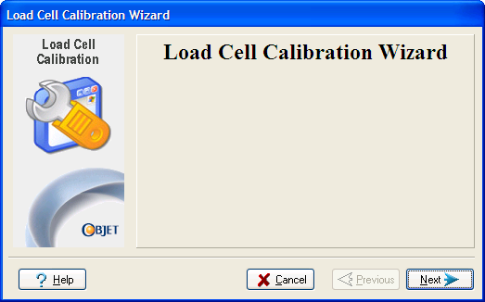
Screen #1
  - screen 2+3: Selection of the cartridges that needs calibration + verification.
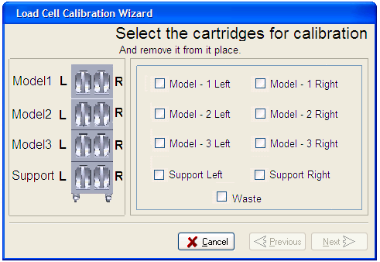
Figure 1
Screen #2

    - The user needs to select the required load cell/s he would like to calibrate. Calibration will be performed only to the “0” point (The screen title and subtitle needs to be revised by a T.W).
    - There are nine load cells. The checkbox positioning in the screen will be located as shown in screen #2 in order to relatively hint to the real location of the load cells in the machine. (The left picture in the screen needs to be supplied by T.W)
    - In the subtitle, the user will be asked to pull out the required cartridges.
    - After selection of at least one checkbox, the “Next” button will be change from disable to enable.
    - After pressing on the “Next” button the SW will verify that all required cartridges indeed removed from the machine. If one or more cartridges were not removed as required, the required cartridges will remain enabled for selection and all other cartridges/waste will become gray – disabled (See the next screenshot sample). As well, the screen title will be change accordingly (T.W)
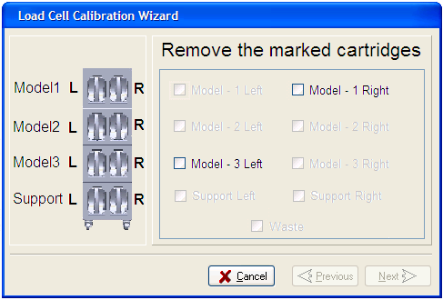
T.W to supply a picture of the cartridge drawer + waste tank
Screen #3
  - Paragraphs 4.7-4.8 will be repeated until all cartridges are removed as required.
  - Screen 4:
    - All A/D will be shown on one screen.
    - After selecting the:”All weights are stable”, the Next button will become enable.
    - Values of load cells that were not selected during the selection phase in screen 2, will be shown in the screen in gray color and disabled.
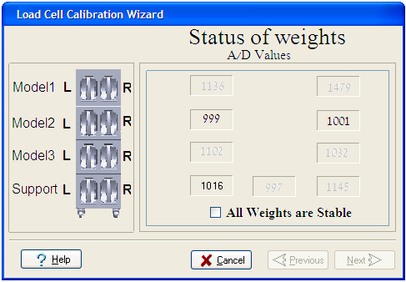
Screen #4

  - Screen 5: Done page.
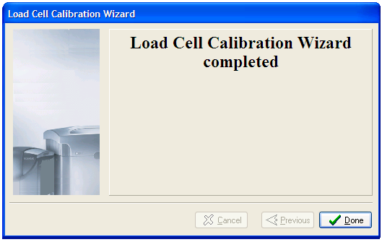

- Load cells calibration area in the maintenance menu
  - Add the drawing as shown below:
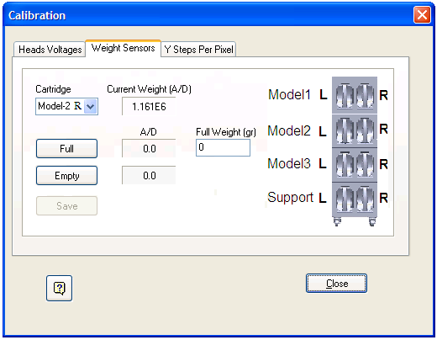

  - T.W needs to define the location of all “Help” buttons

